Name ____________________________
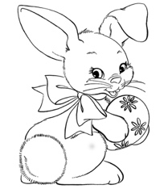

1 2 3 4 5
6 7 8 9 10

