Name ____________________________

G  H 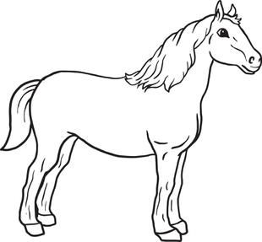

G G H H